**DAILY ONLINE ACTIVITIES SUMMARY**

|  |  |  |  |  |  |  |  |  |
| --- | --- | --- | --- | --- | --- | --- | --- | --- |
| **Date:** | **23-06-2020** | | | | | **Name:** | **Jayraj Shah** | |
| **Sem & Sec** | **6-A** | | | | | **USN:** | **4AL17CS036** | |
| **Online Test Summary** | | | | | | | | |
| **Subject** | | **Java & Python test** | | | | | | |
| **Max. Marks** | | **Java : 10**  **Pythin : 20** | | **Score** | | | **Java : 10**  **Pythin : 18** | |
| **Certification Course Summary** | | | | | | | | |
| **Course** | COVID-19 Tracker APP using React Native and Material UI  MERN Full Stack Development | | | | | | | |
| **Certificate Provider** | | | **N/A** | | **Duration** | | | **App: As per Progress.**  **MERN : 150 lec** |
| **Coding Challenges** | | | | | | | | |
| **Problem Statement:** Write a Java Program to traverse a binary tree using PreOrder traversal without recursion. | | | | | | | | |
| **Status: Completed** | | | | | | | | |
| **Uploaded the report in GitHub** | | | | | **YES** | | | |
| **If yes Repository name** | | | | | **CSE-JayrajShah-4AL17CS036**  <https://github.com/alvas-education-foundation/CSE-JayrajShah-4AL17CS036>  [**DataAnalysis-MachineLearning-with-Python**](https://github.com/JayrajShah/DataAnalysis-MachineLearning-with-Python)  <https://github.com/JayrajShah/DataAnalysis-MachineLearning-with-Python>  [**C-Programming-Placement-Training**](https://github.com/JayrajShah/C-Programming-Placement-Training)  <https://github.com/JayrajShah/C-Programming-Placement-Training> | | | |
| **Uploaded the report in slack** | | | | | **YES** | | | |

Online Test Details: (Attach the snapshot and briefly write the report for the same)

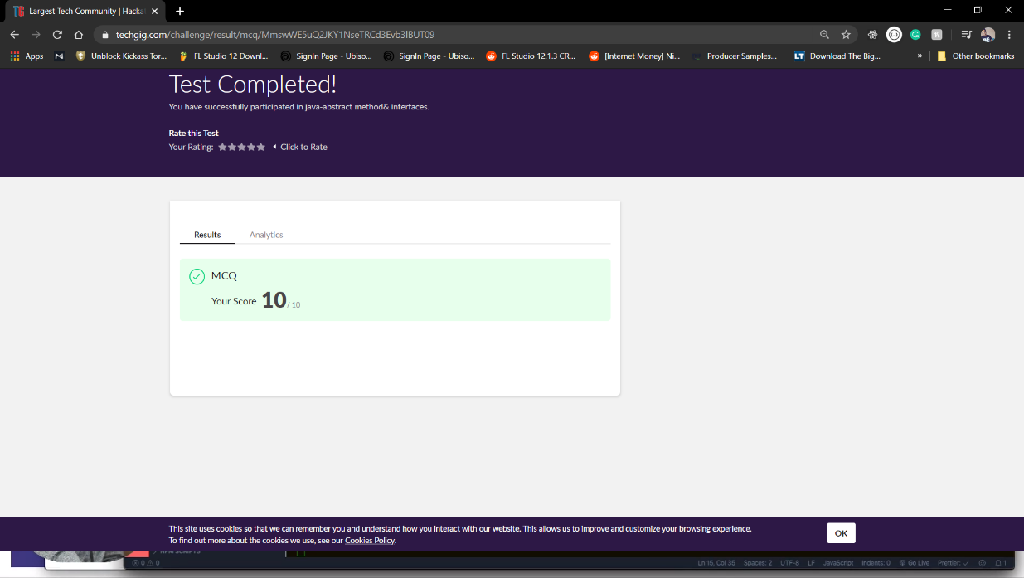

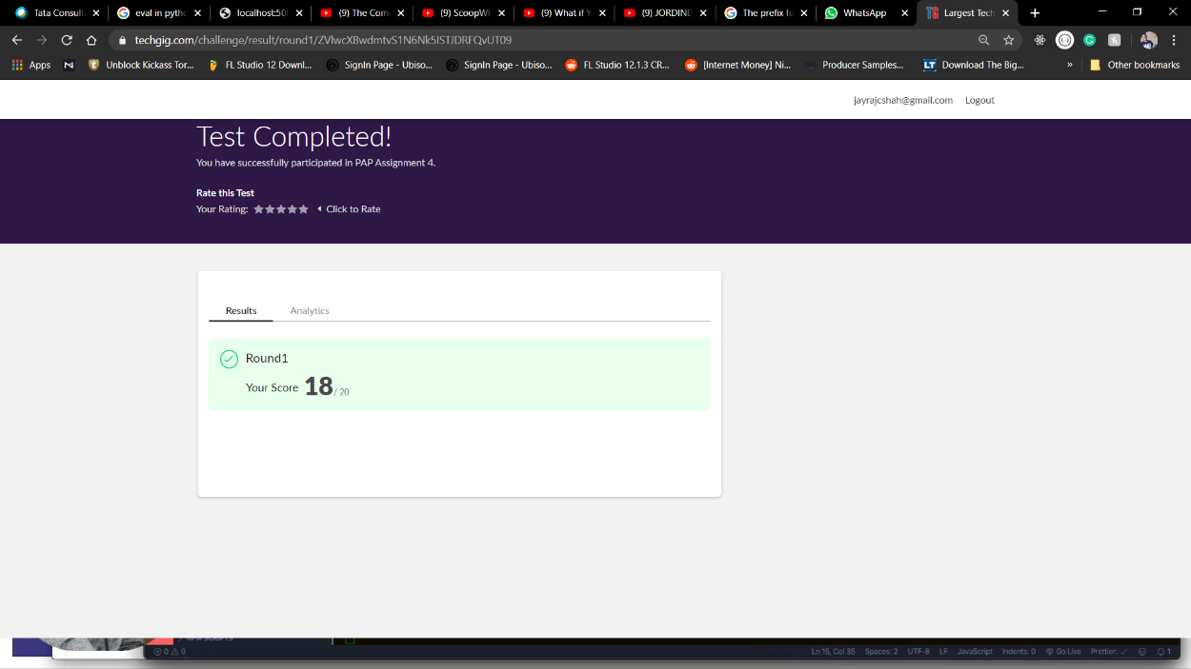

Certification Course Details: (Attach the snapshot and briefly write the report for the same)

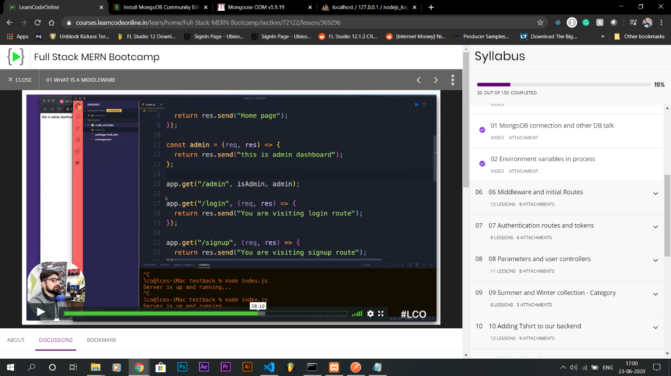

Coding Challenges Details: (Attach the snapshot and briefly write the report for the same)

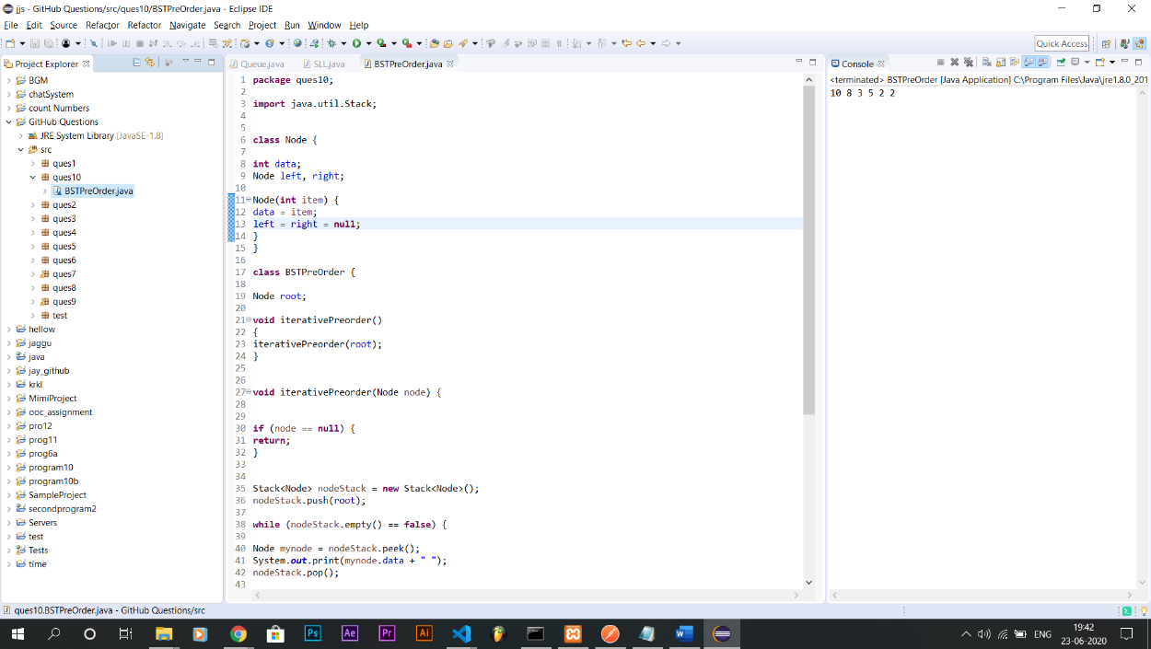

**GitRepo Link :** <https://github.com/alvas-education-foundation/TODO-APP-Jayraj-Shah-CSE-3Year>

(Completed)

<https://github.com/alvas-education-foundation/COVID-19-Tracker-JayrajShah-CSE-3-Year>

(In Progress)

**Course Link :** <https://www.youtube.com/watch?v=qSRrxpdMpVc&t=1671s>

**NOTE: For more description about project, please check out my repositories.**